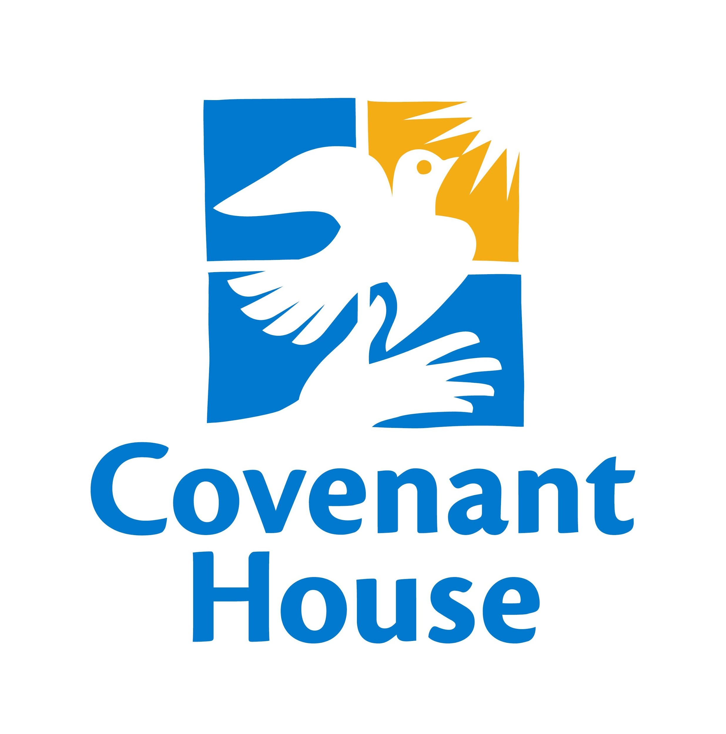 CHILD PROTECTION SYSTEM POLICY MANUAL

Policy Title: Whistleblower System Policy: CPS-14

Affected: Corporate Headquarters and Sites

Issued by: Office of Child Protective Services Date Issued: 11/29/12
Date Revised: 03/01/16

- Purpose:

This policy provides procedures for training staff and volunteers on the use of the whistleblower system.

- Policy:

Covenant House is committed to providing a safe and secure environment for the young people we serve and to ensuring ethical conduct in all aspects of agency operations. New employees, volunteers, interns, and Faith Community members must be provided with information and training on how to use the whistleblower system when they join Covenant House. Existing employees, volunteers, interns and Faith Community members must be brought up to date in whistleblower system training and be retrained annually. Additionally, information on the whistleblower system must be displayed in a minimum of two designated staff areas. Sites must follow local, state, federal, and provincial whistleblower laws in addition to the whistleblower system.

- Procedure:

- New employees, volunteers, interns, mentors, and Faith Community members must receive written materials and training on the purpose and use of the whistleblower system during the orientation stage of their association with Covenant House.
- On an annual basis, existing employees, volunteers, interns, and Faith Community members must receive training on the purpose and use of the whistleblower system.
- Information on the whistleblower system must be displayed in a minimum of two designated staff areas.
- The whistleblower System will be administered by the Director of Child Protective Services in the U.S., and in partnership with local site leadership abroad.

